Task Description:

Create the K8s EKS,further you have to do the deployment of the Nginx application and access the application outside the cluster.

Step-1: Create AWS CLI
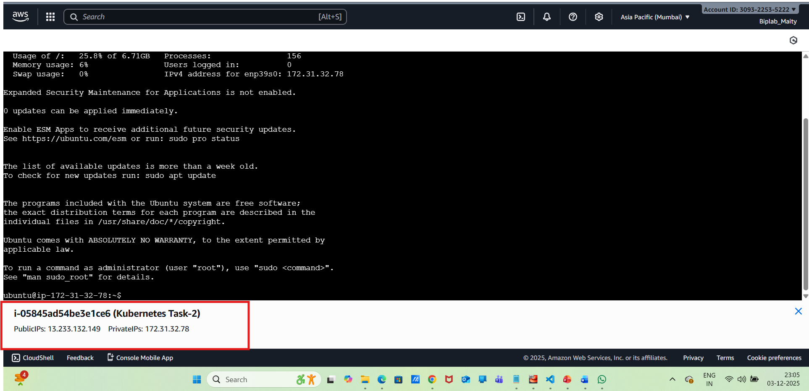
Then perform the commands below
sudo apt update -y
curl "https://awscli.amazonaws.com/awscli-exe-linux-x86_64.zip" -o "awscliv2.zip"
Sudo apt install unzip
unzip awscliv2.zip
sudo ./aws/install
aws --version
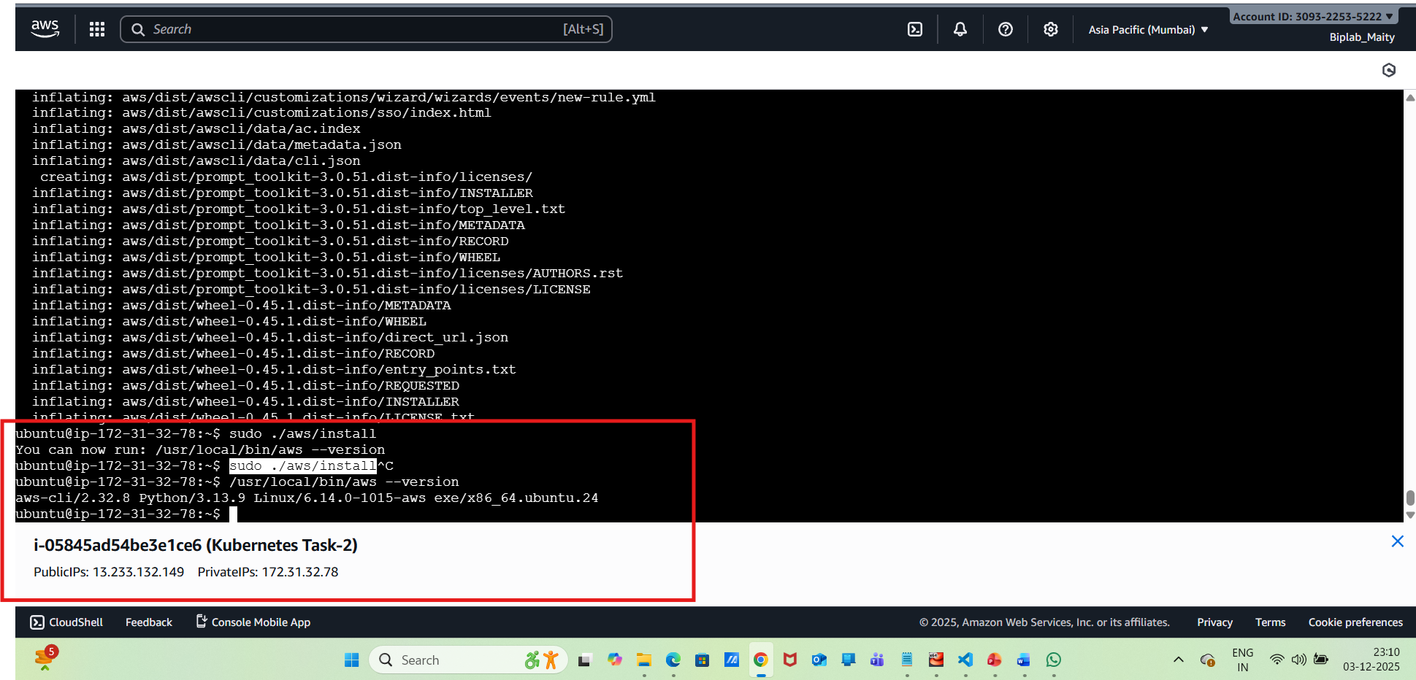
aws configure
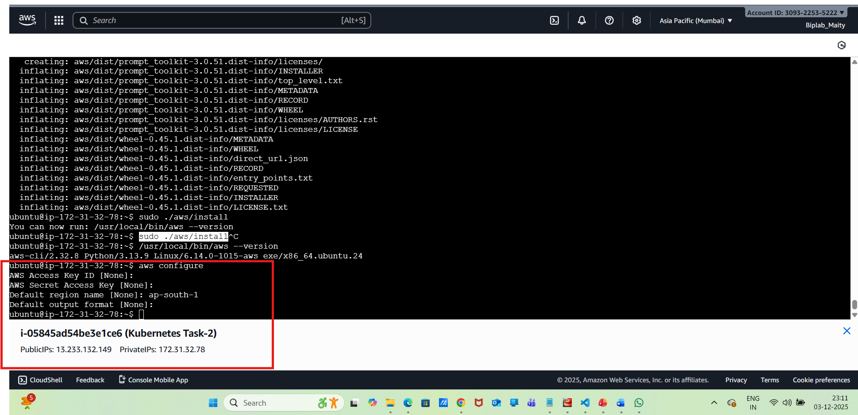
Step-2: Now Install eksctl
curl --silent --location "https://github.com/eksctl-io/eksctl/releases/latest/download/eksctl_$(uname -s)_amd64.tar.gz" -o eksctl.tar.gz
tar -xzf eksctl.tar.gz
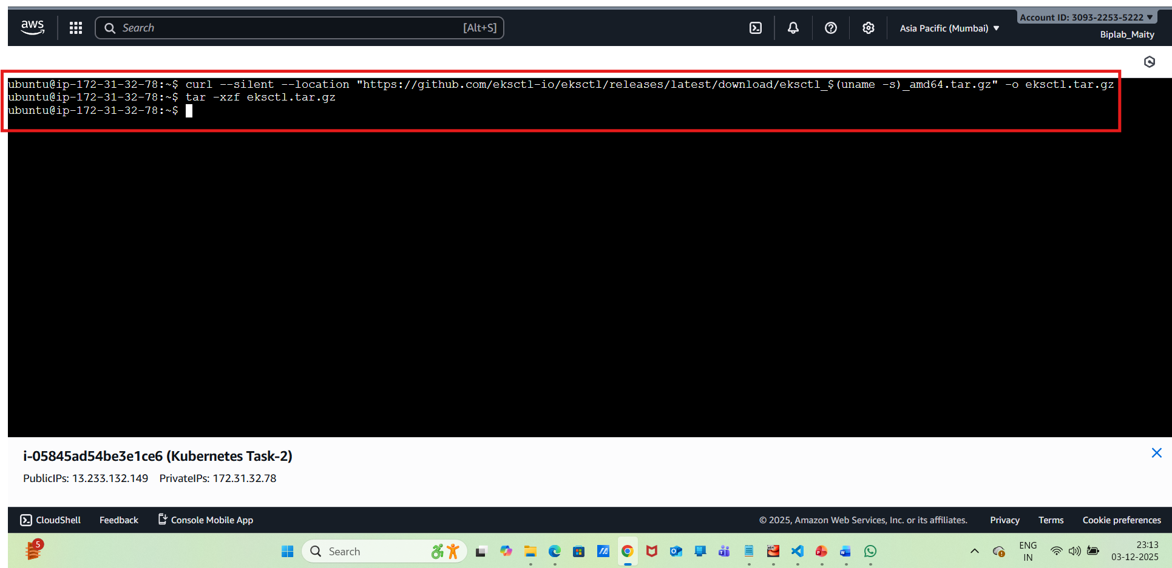
Need to move eksctl to /usr/local/bin path
sudo mv eksctl /usr/local/bin
eksctl version
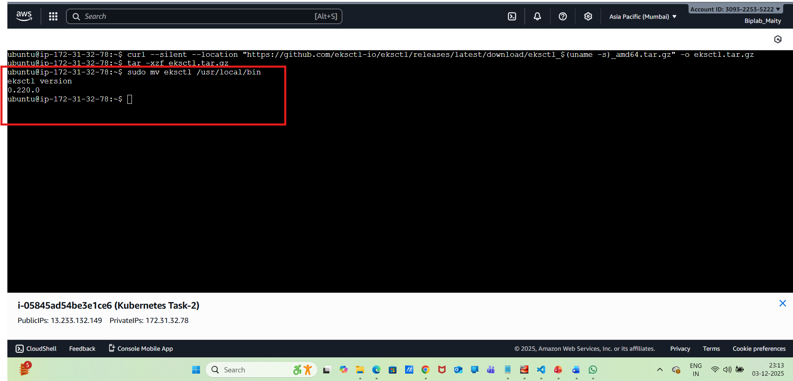
Step-3:Install kubectl
curl -LO "https://dl.k8s.io/release/$(curl -L -s https://dl.k8s.io/release/stable.txt)/bin/linux/amd64/kubectl"
chmod +x kubectl
sudo mv kubectl /usr/local/bin
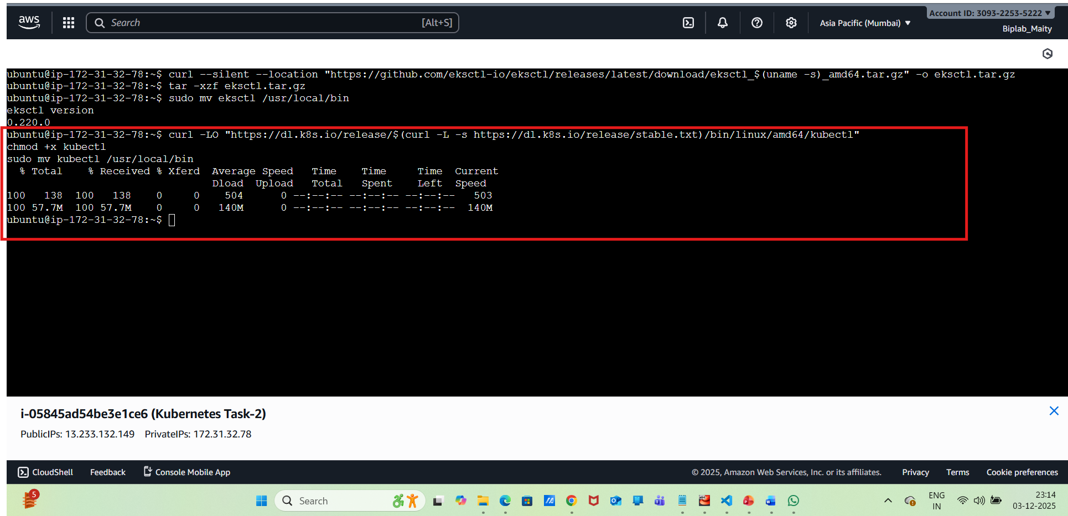
Step-4:Need to create an EKS Cluster using eksctl
create vi cluster.yaml
apiVersion: eksctl.io/v1alpha5
kind: ClusterConfig

metadata:
name: demo-eks-cluster
region: ap-south-1
version: "1.29"

nodeGroups:
- name: ng-general
instanceType: c7i-flex.large
desiredCapacity: 2
volumeSize: 20
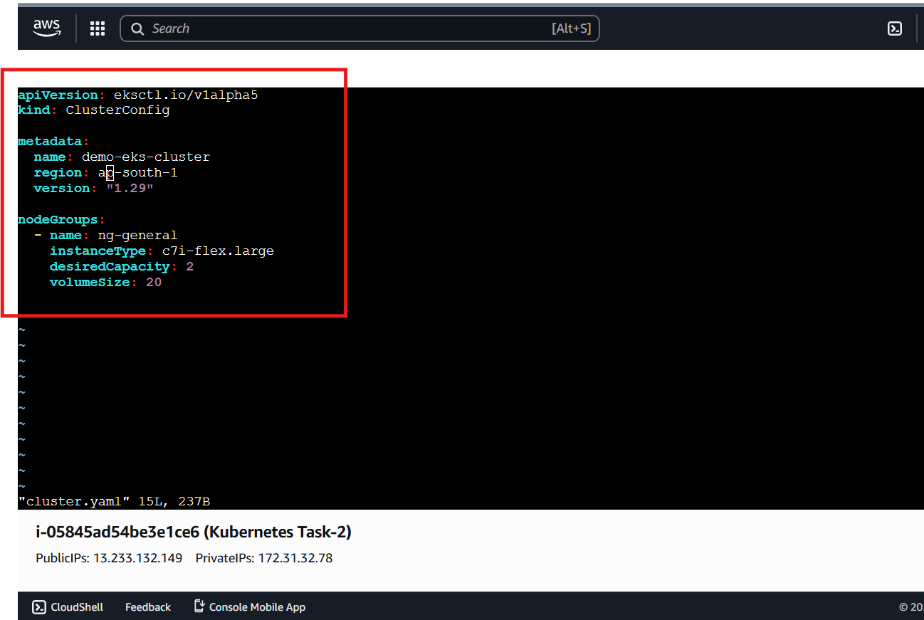
need to go to AWS Console → IAM → Roles → Create Role
Now, we need to create a cluster :
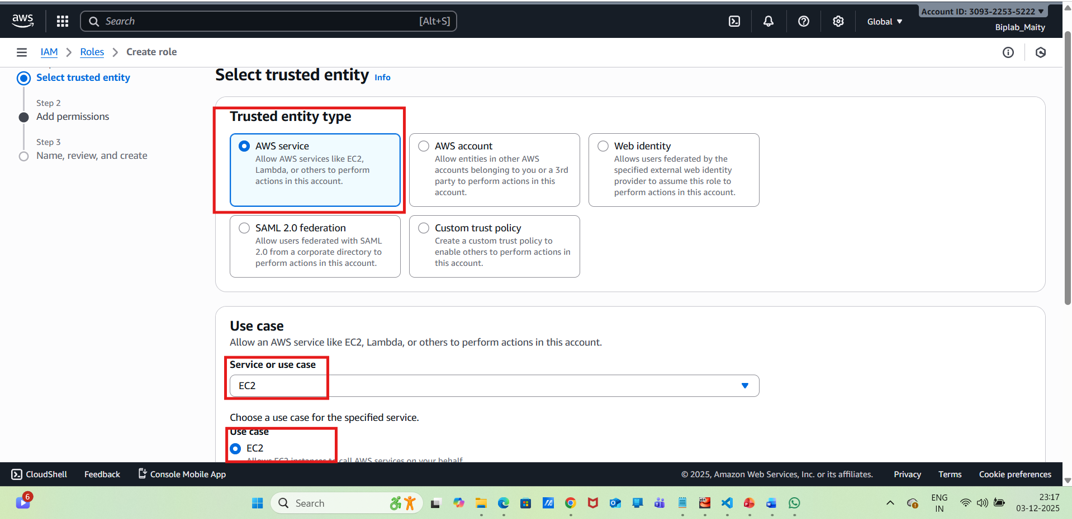
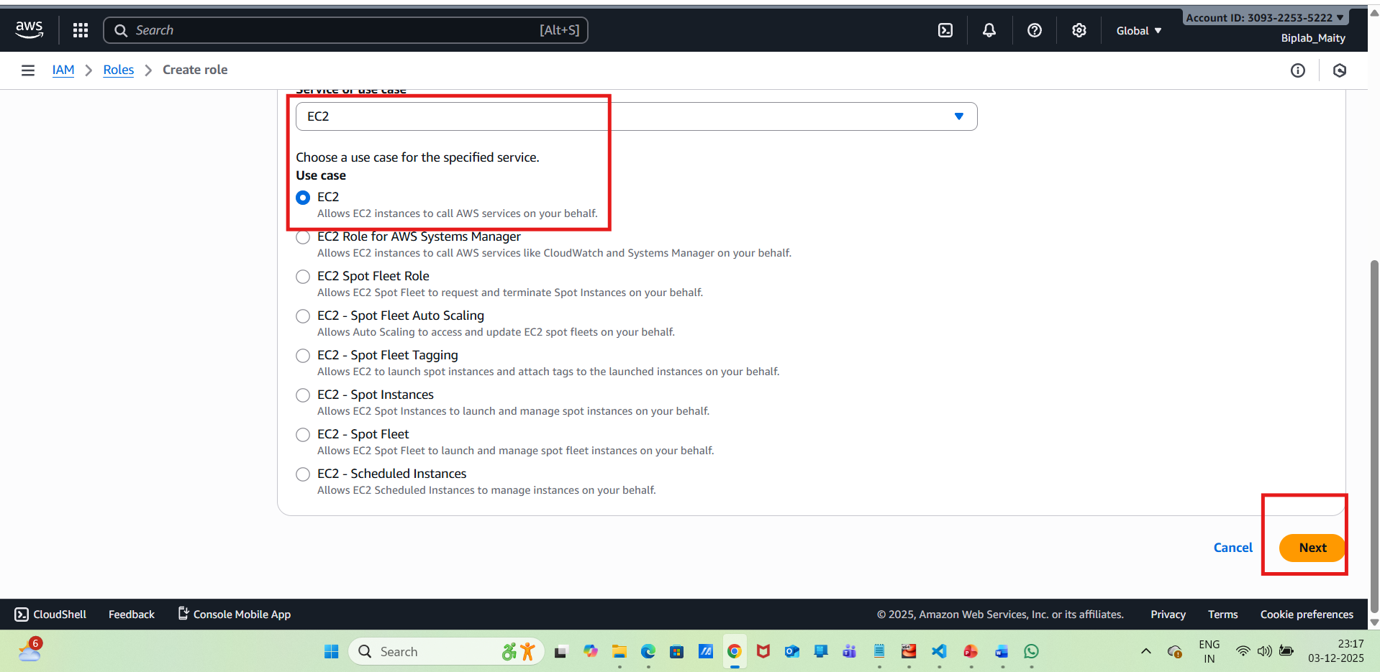
Need to attach the below roles
AmazonEKSClusterPolicy
AmazonEC2FullAccess
AmazonEKSServicePolicy
AmazonEKSWorkerNodePolicy
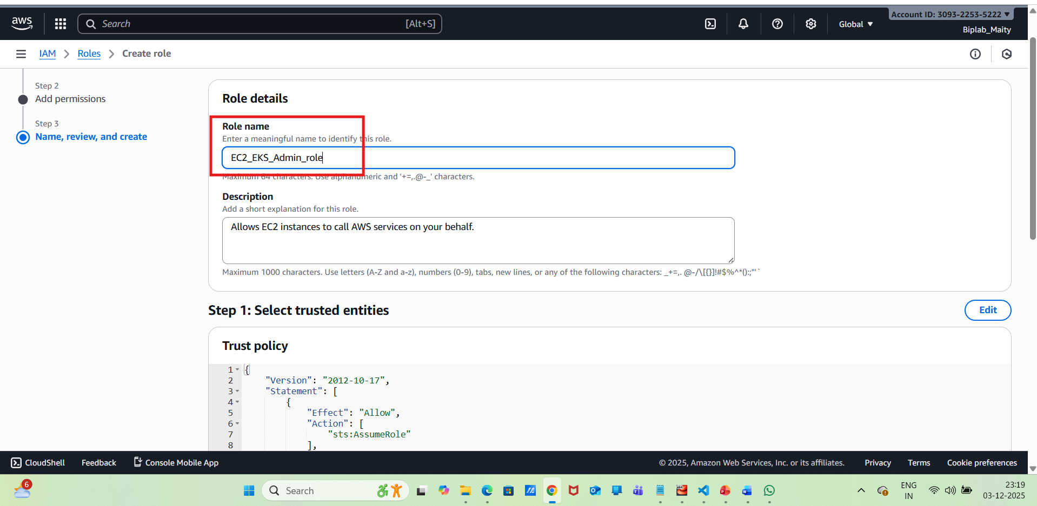
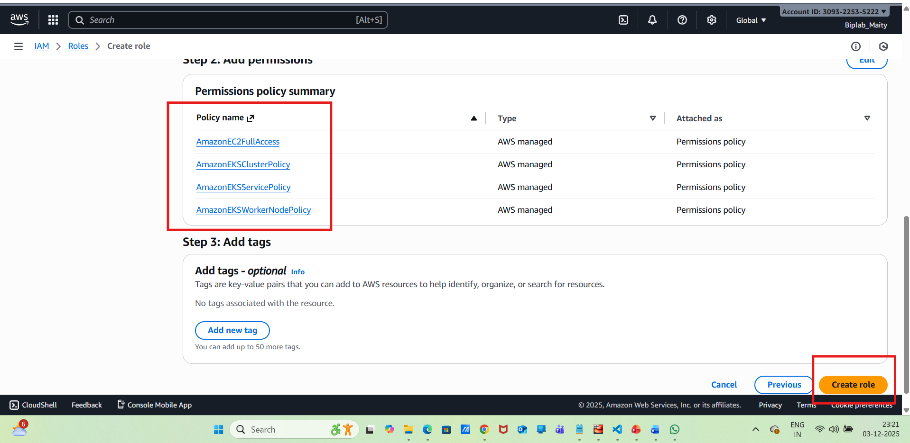
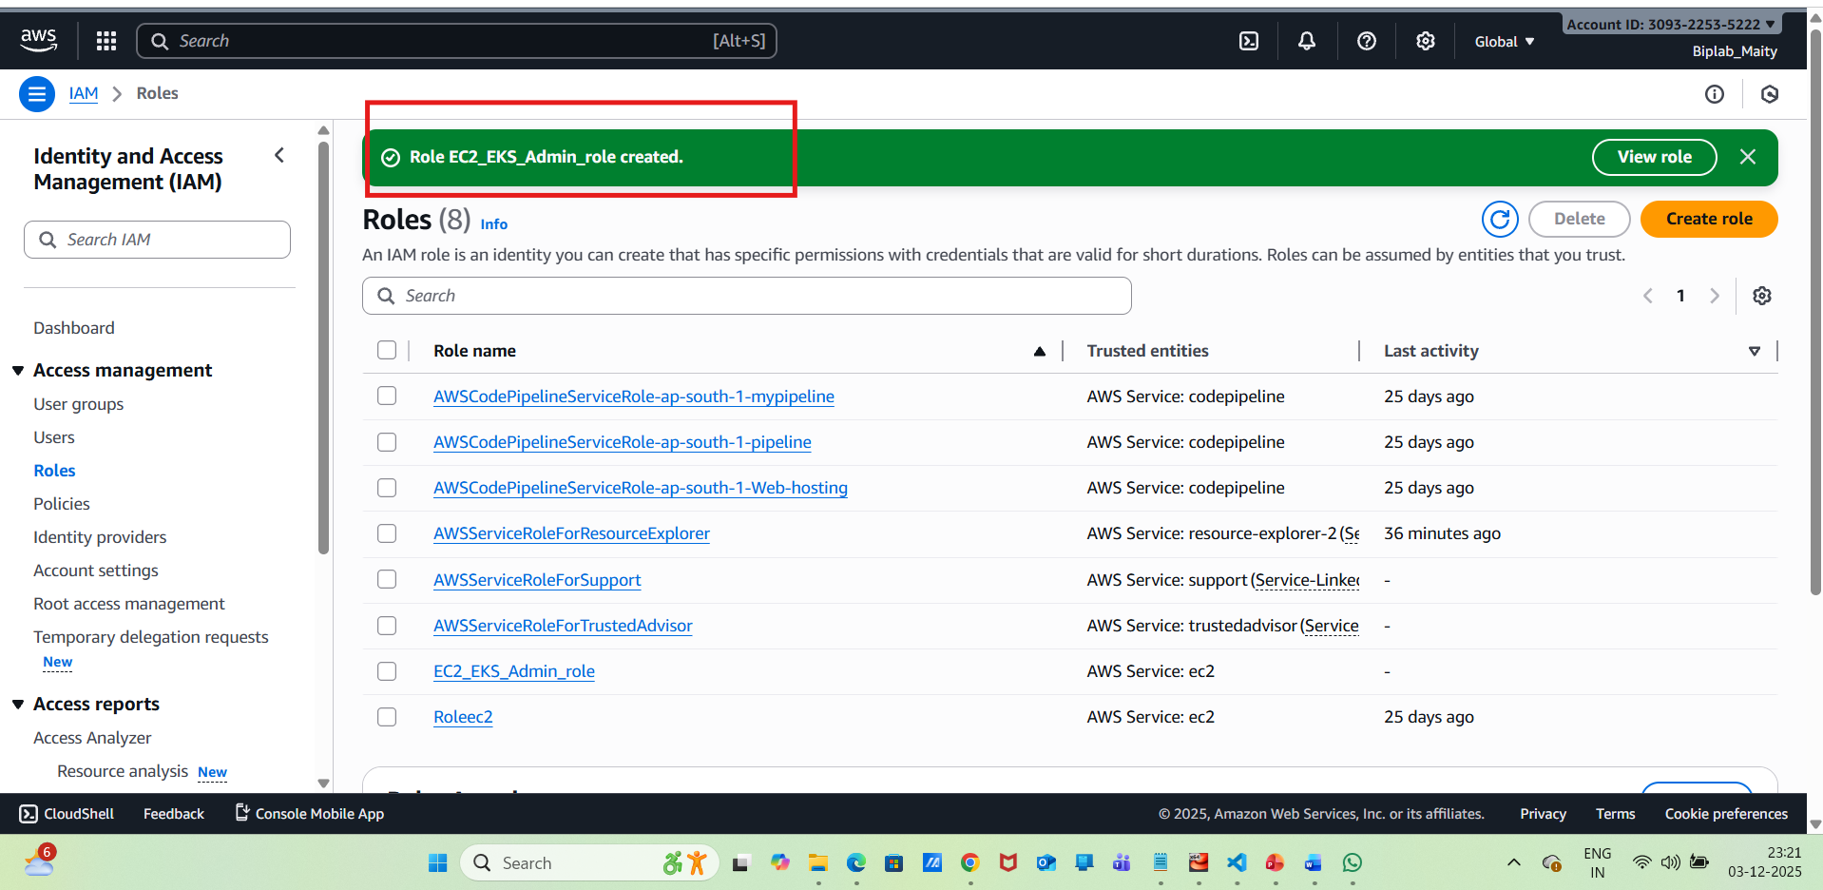
Now need to Attach the role to your EC2 instance
AWS Console → EC2 → Instances → Select instance
→ Actions → Security → Modify IAM role → select EC2-EKS-Admin_role
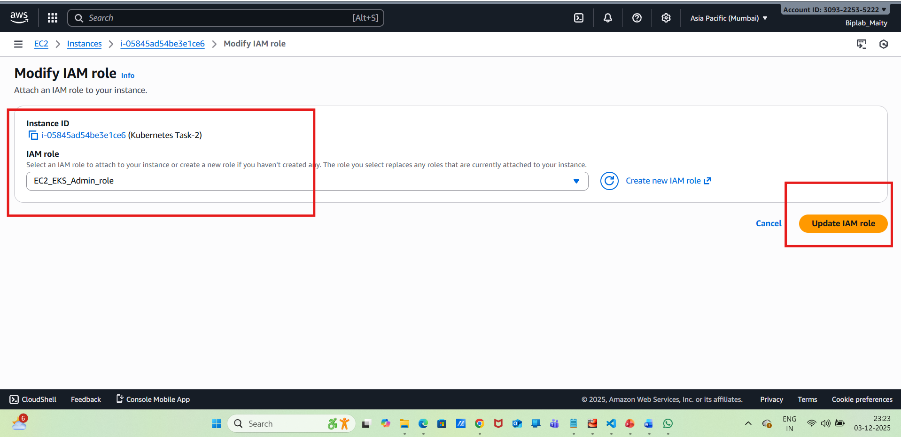
Verify IMDS is working in CE2 or not :
curl http://169.254.169.254/latest/meta-data/iam/security-credentials/
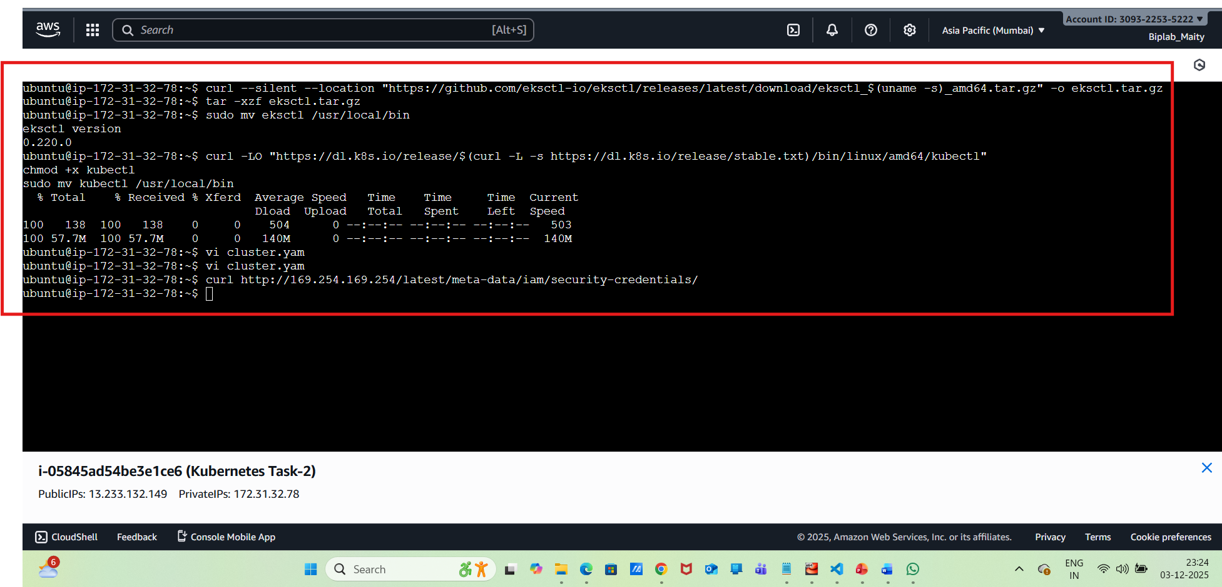
Now we need to apply via the command below
eksctl create cluster -f cluster.yaml
Error:
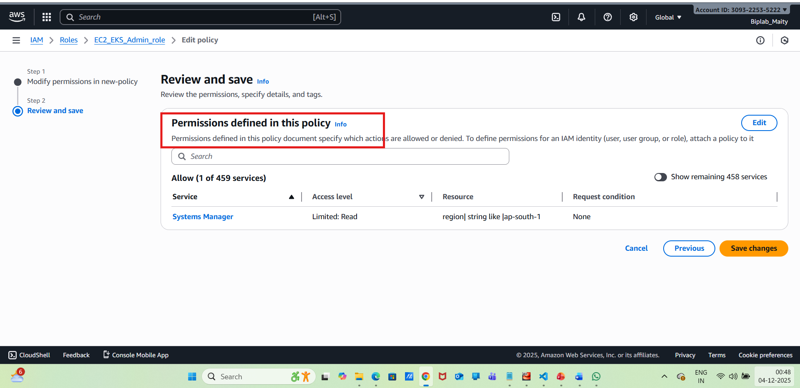
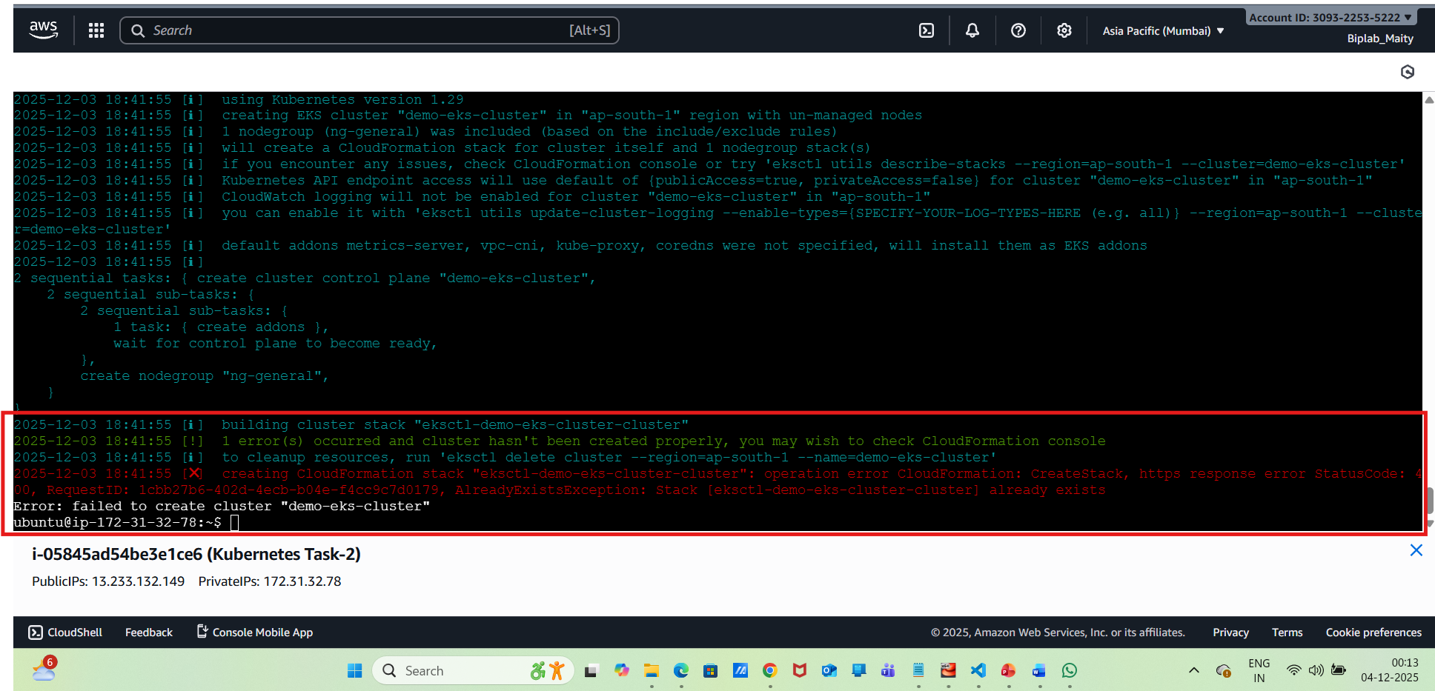
Need to Go to the CloudFormation console in ap-south-1 and run:
aws cloudformation describe-stacks --region ap-south-1
need to Update kubeconfig
aws eks update-kubeconfig --name demo-eks-cluster --region ap-south-1
Need to verify cluster connection:
kubectl get nodes
Step-6:Deploy Nginx Application
Create Deployment
kubectl create deployment nginx --image=nginx
Check deployment:
kubectl get deployments
kubectl get pods
Step-7:Expose Nginx Outside Cluster (LoadBalancer)
To expose the service over the internet:
kubectl expose deployment nginx \ --port=80 \ --type=LoadBalancer
Verify service:
kubectl get svc nginx
Step-8:Cleanup Resources by below commands
eksctl delete cluster --name demo-eks-cluster --region ap-south-1

